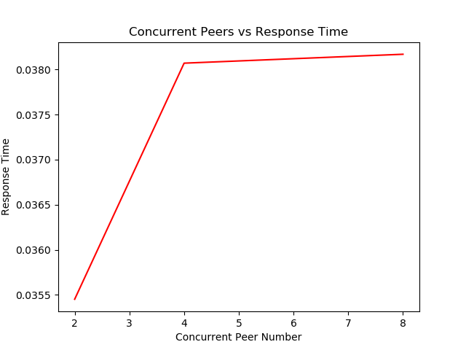CS550 Advanced Operating System

Programming Assiggment 1

Meng Tang A20455416

Output Files & Performance Evaluation Results

**Overview**

Make file runs query response time tests and file transfer time tests. Then it organizes all the test output log files into a folder named test-logs.

**Tests Description**

The response time tests measures 2, 4, and 8 concurrent peers to test for index-server response time. Each peer will request to download one file, with a total of 60 requests. Time measured between the download request is sent to the index server and when the peer receive a reply from the index server. The averaged recorded time is recorded in the regular peer log file.

The file transferred time is measured with 4 concurrent peers requesting to download 5 files of different sizes. The sizes are 128 bytes, 512 bytes, 2kb, 8kb, and 32kb. Time is recorded between the one file name is sent to the peer, and after the file is written to local directory.

**Output and Graphs:**

Figure1. Concurrent Peers Number vs Response Time.

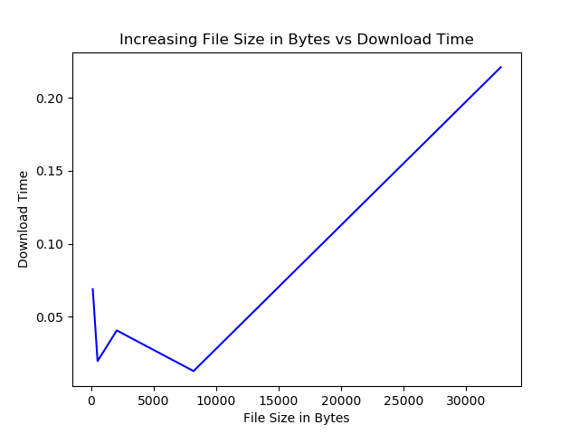4 Concurrent peers have a huge response time increase from 2 concurrent peers, while the 8 concurrent peers have less increase from 4 concurrent peers. The smaller time increase can also be due to that some of the peers in the 8 concurrent peers had unstable connection and was terminated in the test before it was able to finishes all requests. Those data is not included in the resulting graph, but it could contribute to less than 8 concurrent peers are sending requests for some amount of times.

Figure 2. Increasing File Sizes in Bytes vs Download Time.

The download time is the fastest with 8k files, then 512bytes, 2k files, 128bytes files, and the slowest 32k files. Very different comparing to the results from programming assignment 1, where the test was run on a Linux Virtual Machine and resulting in 32k files the fastest and 128 bytes files the slowest.